Data Description
Workbook 1 Spreadsheet Title: 1905 Land Own- Land Cover Data-includes data quality testing- 1-20-10

Worksheet pages
- Location information
- Column A: Site ID: Spatially identifies unit of analysis in relation to the US Public Land Survey System. This 8-digit code identifies the unit of analysis to the quarter-section scale.
8-digit code can be read as follows:
First digit, i.e., “2” indicates east vs. west location of township in relation to the Fourth Principle Meridian line.
Second and third digit: Indicates township
Fourth and fifth digit: Indicates range
Sixth and seventh digit: Indicates Section
Eighth digit: Indicates quarter section: “1”: NE quadrant; “2”: NW quadrant; “3”: SW quadrant; “4”: SE quadrant
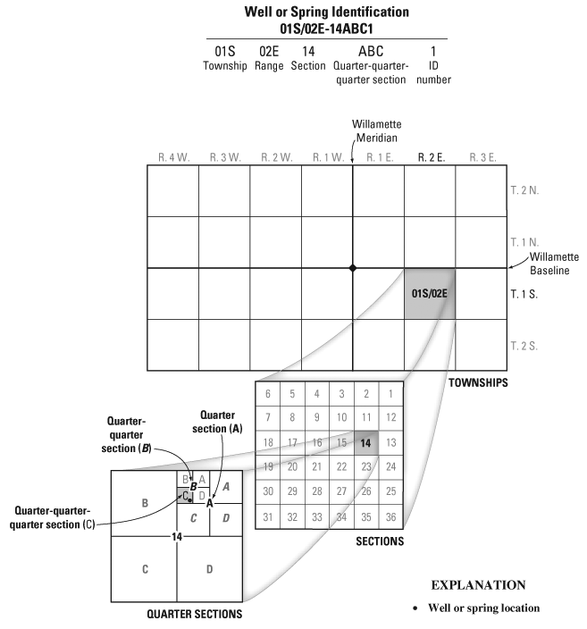
- Column B: x-coordinate: Centroid of quarter-section in latitude
- Column C: y-coordinate: Centroid of quarter-section in longitude

- Land Cover Information
Column A-C: Site ID; x-coordinate; y-coordinate
Column D: 1857 land cover
Column E: 1930 land cover
Column F: 1987 land cover-fewest categories
Column G: 1987 land cover-categories include “Lowland Forest” and “Pine Species”; In contrast in Column F, these categories with relatively few observations were grouped with “Other or No Data”
Of these two, choose the dataset that makes most sense statistically.

If desired, land cover information are available in more detailed form, which I included in the dataset. I have left these data in their original coded form, but can provide the code details, should this be desired.
Column H: 1857 land cover- detailed
Column I: 1930 land cover- detailed
Column J: 1987 land cover- detailed

- 1905 Land Cover Information
Note that what is presented here is the definition only; hypothesized relationships among variables presented in communication of Jan. 11, 2010.
Column A: Site ID
Column B: x-coordinate: Centroid of quarter-section in latitude
Column C: y-coordinate: Centroid of quarter-section in longitude

Column D: 1905 ownership class- revised; I recommend using this revised variable: classes with few observations have been collapsed into classes with many observations.
Column E: 1905 ownership class- original, raw data, if desired for additional reference beyond the revised, grouped classes.

Column F: on/off reservation location- Recommended revised format: ("1"-Res; "0"- Off-res)
Column G: Res vs NonR- Original format ("0"-Res; "1"- Off-res)

“Continuous covariates (include all that are of interest, not just the ones
that are significant in MLR analysis: parcel info, elevation, soil, etc).” Note: Per correspondence of 1/14/10, we agreed to begin with the original dataset, excluding the soil and elevation data developed after the dissertation was complete.

Column H: POLYNUM: a measure of parcel density of quarter-section. Using the GIS, we quantified the number of parcels that lay in whole or in part within a given quarter-section.
Column I: PRAVPOLY: A measure of parcel size in relation to quarter-section unit of analysis. This variable reports average size of parcel polygon, as a proportion of quarter-section in which polygon lies. Note: Because this variable is bounded by the quarter-section boundary, this variable does not necessarily report data on the entire parcel, if part of the parcel lies outside of the quarter-section. For ex., A quarter-section may contain part (polygon) or whole of three parcels: Parcel A: polygon- 80 acres lies in qu-section of a 160 acre parcel; Parcel B: 40 acres (polygon) in qu-section, which accounts for entire parcel; Parcel C: 40 acres (polygon) in qu-section of a total 80 acre parcel: The value here would be (80 + 40 + 40)/ 3 = 53.3, then would be presented as a proportion of the quarter-section, realizing that quarter-sections vary from the ideal 160 acre size.
The goal here was to develop a variable that was entirely contained by the quarter-section unit of analysis and thus to have complete spatial correspondence between the independent and dependent variables.
N.B. In some cases, the proportional data > 1.0; this is due to rounding error. I would suggest limiting analysis to about 3 significant digits.
Column J: MXPOLYPR: A measure of parcel size in relation to quarter-section unit of analysis. This variable reports largest parcel polygon in quarter-section, as a proportion of quarter-section in which polygon lies.
As in “PRAVPOLY”, the goal was to develop a variable that was entirely contained by the quarter-section unit of analysis and thus to have complete spatial correspondence between the independent and dependent variables.

Column K: TOTOWN: A measure of property area in entire study area: Total property area (measured in acres) in study area associated with owner of largest parcel polygon in quarter section.

Column L: “Av Parcel Sz”: A measure of the average parcel size associated with a given quarter-section, measured in acres. E.g., a quarter-section may contain parts of two parcels: 1) a 160 acre parcel, having 80 acres inside that quarter-section and 80 acres outside; 2) an 80-acre parcel. Thus, the average parcel size associated with that qu-section is (160 + 80)/ 2 = 120.
N.B.: This variable was not included in multinomial regression analysis at time of dissertation, but upon later consideration, this seems like a meaningful and interpretable variable. A possible shortcoming is that the data are presented in acres, not as a proportion (as in the proportional variables), so don’t factor into analysis relative quarter-section size (which varies from 128 acres to 226 acres, in comparison to the ideal 160 acres).

Column M: “Av Parcel Sz-Pr”: A measure of the average parcel size associated with a given quarter-section, measured as a proportion of quarter-section.

Column N: quarter-section presented in acres
Columns O, P, and Q are also appended, but they are present as an alternative only if analysis with the other variables is not successful.
- For reference, entire dataset, if needed. Details available upon request.
- Quarter-section size, measured in acres.

***********************************************************************
FORTHCOMING WORKBOOKS
ASSUMING THE ABOVE FORMAT AMPLY MEETS THE PROJECT NEEDS, FORTHCOMING WORKBOOKS WILL EMPLOY THE SAME FORMAT.

Workbook 2: 1915 Land Ownership Information

Workbook 3: 1958 Land Ownership Information

Workbook 4: 1987 Land Ownership Information

